Vishnuteja Thummanapelli (2671322)

Sri Vishnu theja Yadalam (2670801)

Abstract

An application that uses real-time streaming data from Wikipedia to determine whether an edit made to page was by Bot or not using modern Big data and analytic tools like Kafka, Spark etc.,

CIS-612

Big data project – Wikipedia Bot or Not

**Project Report**

**Wikipedia – Bot or Not**

**CIS - 612 Big Data and Parallel Processing systems**

VishnuTeja Thummanapelli (2671322), Sri Vishnu Theja Yadalam (2670801)

**Problem Statement**

Wikipedia being the largest community of encyclopedia, most of the content is contributed by human. But it also has bots which automate the content writing into Wikipedia. Wikipedia publishes a stream of edits that are made to each of its articles and it provides a bunch of different information in that stream it provides the name of the user, type of edit that was made, how big it was made and the time when the edit was made. The aim is to predict whether the edit is made by the human or a bot.

**Tools used**

***Apache Kafka:*** For accessing real time streaming data from Wikipedia. It is a distributed streaming Platform. It allows to publish and subscribe to stream of records and stores them in a fault tolerant way by processing the stream of records as they occur.

Kafka runs as a cluster on one or more servers. The cluster stores the stream of records in categories called topics. Each record consists of a key, a value, and a timestamp.

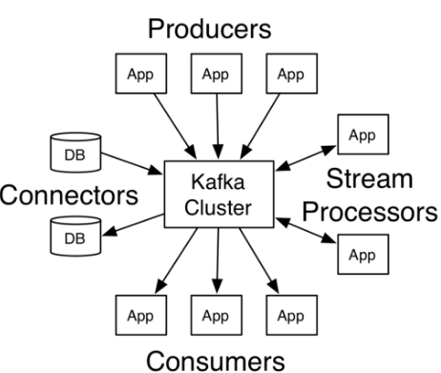

In our application, Kafka acts as both consumer and producer. While accessing the data from Wikimedia API, it is consumer. It produces three topics, in which case it acts as producer.

• The Producer API allows an application to publish a stream of records to one or more Kafka topics.

• The Consumer API allows an application to subscribe to one or more topics and process the stream of records produced to them.

• The Streams API allows an application to act as a stream processor, consuming an input stream from one or more topics and producing an output stream to one or more output topics, effectively transforming the input streams to output streams.

• The Connector API allows building and running reusable producers or consumers that connect Kafka topics to existing applications or data systems. For example, a connector to a relational database might capture every change to a table.

***Apache Zookeeper***: Zookeeper is a server to manage Hadoop and its technology stack for the communications running between various components. It uses <K, V> pairs for configuration management and naming. It is an open source server for managing distributed communications. It helps to keep Kafka servers running and manages the co-ordination between Kafka topics.

***Apache Spark:*** Apache Spark is a fast and general engine for big data processing, with built-in modules for streaming, SQL, machine learning and graph processing. It uses in-memory data processing for easier data processing faster and distributed.

We have used Apache Spark in Python for connecting to Kafka topics to consume data every 2 seconds, process the data, store in Database and then apply Machine Learning on the received data.

***PostgreSQL:*** A relational database for persistent storage. In our case it is used to create three tables for storage and fetching.

***Python:*** Python is a scripting language which has PySpark libraries and kafka streaming libraries for easier access to the nodes of Kafka.

**Data fetching**

The Wikipedia data was fetched using hello-kafka-streams (A well-documented library to access the real-time edits data from Wikimedia API) developed in JAVA, obtained from developer community GitHub using IRC Wikimedia API.

For processing data produced by Kafka nodes in real-time streaming. And for storing data in database and for machine learning.

**Architecture**

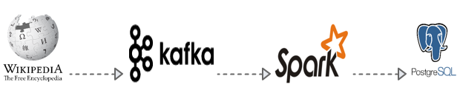

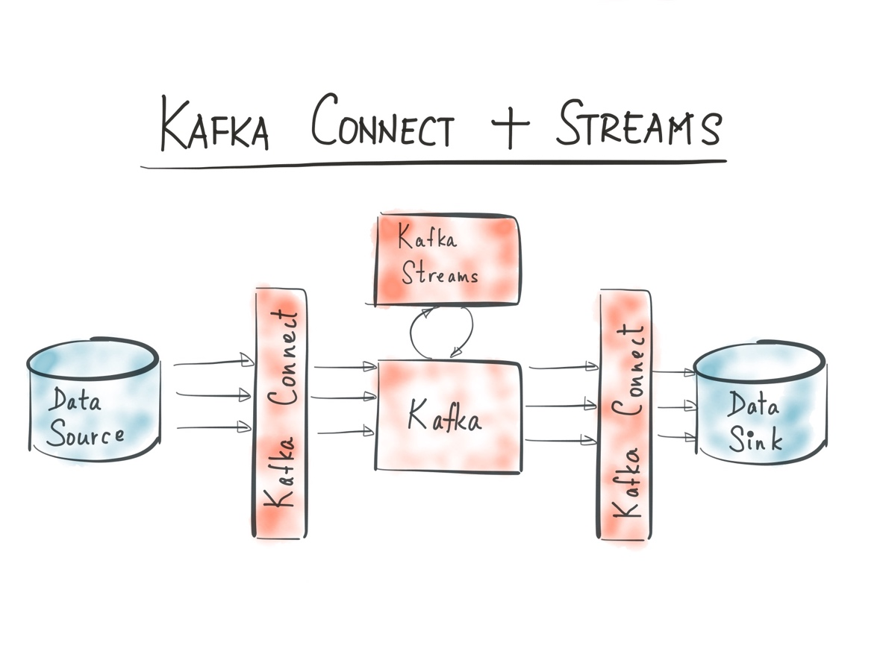

Wikipedia is a large encyclopedia, maintains a vast amount of Big Data and edits are made every second and the information regarding the edits are also stored in the log. Hello – Streams – Kafka is a code developed in Java helps to fetch the Wikipedia data through IRC Wikimedia API and the Kafka helps to stream the real-time data obtained from Wikipedia. Machine Learning had been applied using Python in Spark and along the edited information the prediction is also stored in PostgreSQL.

**Installation setup:**

Install Scala, Kafka and Spark from homebrew with following commands in macOS/OS X. Kafka installs Zookeeper.

$ brew search apache-spark

$ brew install spark scala sbt

$ brew search scala

$ brew install scala

$ brew search kafka

$ brew install kafka

Spark can be tested using $spark-shell

**Python 3.5** is to be installed for the application to run. Some of the Spark’s new version are incompatible with versions later 3.5.

**Anaconda** can be used to manage the Python versions installation and updates. It can also be used to manage further packages on Python. <https://www.continuum.io/downloads#macos>

After installation of Anaconda, the following commands can be run to setup Python 3.5

$anaconda

$conda create –n py35 python=3.5 anaconda

$activate py35

PostgreSQL can be installed using <https://postgresapp.com>.

Once installed, postgres can be run using

"/Applications/Postgres.app/Contents/Versions/9.6/bin/psql" -p5432 -d "vishnuteja"

After the setup, the Bash profile file is to be updated with new environment variables for all the communications.

export PATH="/Users/vishnuteja/mongodb/bin:$PATH"

export KAFKA_HOME="/usr/local/Cellar/kafka/0.10.2.0"

export PATH=$KAFKA_HOME/bin:$PATH

For the hello-kafka-streams to run Gradle build services should be installed.

brew install gradle

Once installed, one has to clone the github project for the kafka(Wikipedia) to run.

git clone https://github.com/amient/hello-kafka-streams.git hello-kafka-streams

cd hello-kafka-streams/

./gradlew build

**Zookeeper Start**

First step is to start the Zookeeper server in our local machine using the following command from kafka bin folder.

./bin/zookeeper-server-start ./libexec/config/zookeeper.properties &

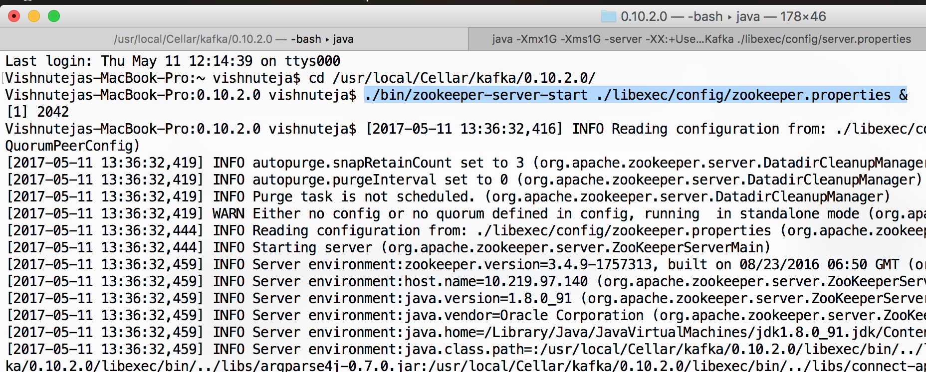

The zookeeper runs on Localhost:2181

**Kafka server**

Run the kafka server with the following command

./bin/kafka-server-start ./libexec/config/server.properties

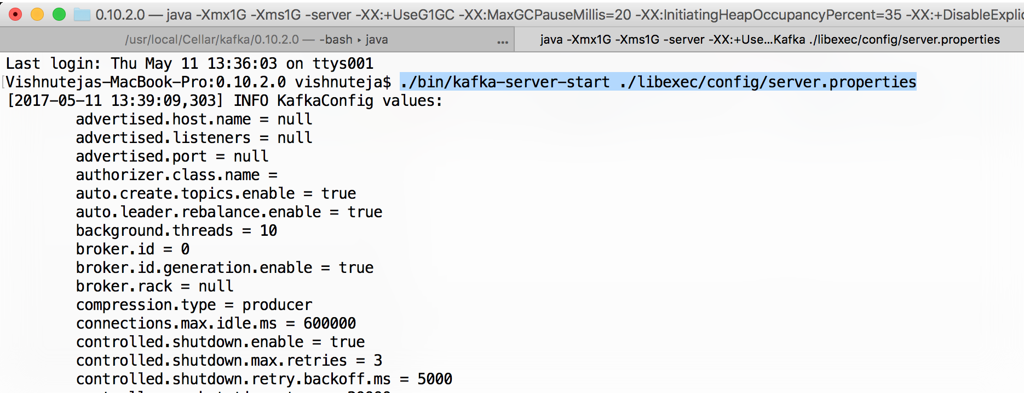

Kafka then communicates with Zookeeper for sync.

[2017-05-11 13:39:09,480] INFO Initiating client connection, connectString=localhost:2181 sessionTimeout=6000 watcher=org.I0Itec.zkclient.ZkClient@29626d54 (org.apache.zookeeper.ZooKeeper)

[2017-05-11 13:39:09,504] INFO Waiting for keeper state SyncConnected (org.I0Itec.zkclient.ZkClient)

[2017-05-11 13:39:09,510] INFO Opening socket connection to server localhost/0:0:0:0:0:0:0:1:2181. Will not attempt to authenticate using SASL (unknown error) (org.apache.zookeeper.ClientCnxn)

[2017-05-11 13:39:09,598] INFO Socket connection established to localhost/0:0:0:0:0:0:0:1:2181, initiating session (org.apache.zookeeper.ClientCnxn)

[2017-05-11 13:39:09,615] INFO Session establishment complete on server localhost/0:0:0:0:0:0:0:1:2181, sessionid = 0x15bf89567a70000, negotiated timeout = 6000 (org.apache.zookeeper.ClientCnxn)

[2017-05-11 13:39:09,617] INFO zookeeper state changed (SyncConnected) (org.I0Itec.zkclient.ZkClient)

**Create topics(nodes) on Kafka server**

We need to then create three topics Wikipedia-raw, Wikipedia-parsed, Wikipedia-streams-wikipedia-edits-by-userlog.

These three topics are used by hello-kafka-streams when run to publish data to these topic nodes.

./bin/kafka-topics --zookeeper localhost --create --topic wikipedia-raw --replication-factor 1 --partitions 4

./bin/kafka-topics --zookeeper localhost --create --topic wikipedia-parsed --replication-factor 1 --partitions 4

./bin/kafka-topics --zookeeper localhost --create --topic wikipedia-streams-wikipedia-edits-by-user-changelog --replication-factor 1 --partitions 4

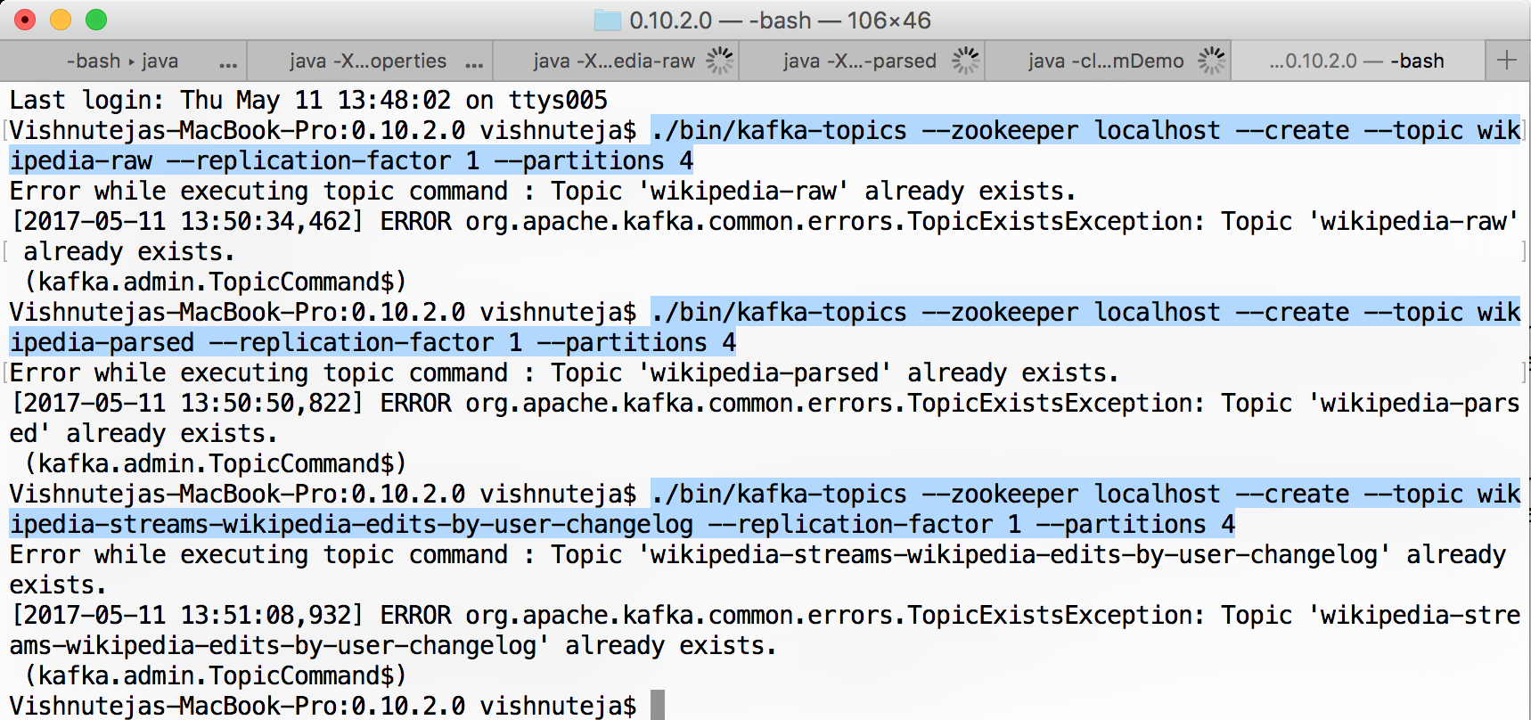

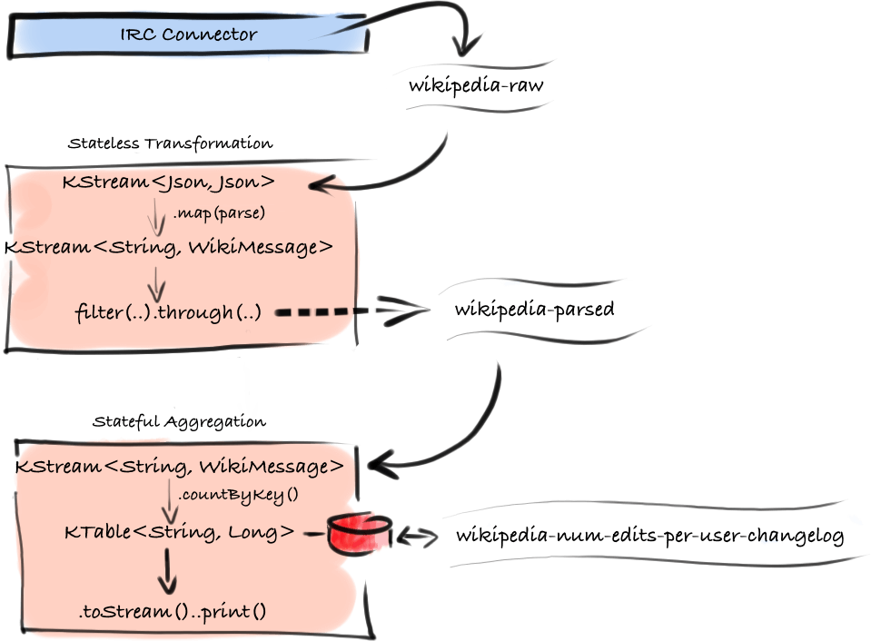

**Run hello-kafka-streams**

After the github project is cloned, we must build the application using Gradle.

./build/scripts/hello-kafka-streams

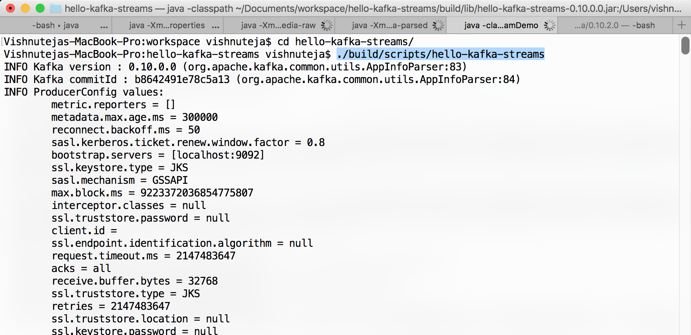

Once the application is run, it accesses the topic nodes we created in Kafka to publish the Wikipedia live edits data.

**Users**

The console of the program displays who are the currently editing the Wikipedia pages.

Here is a screenshot of the program’s output.

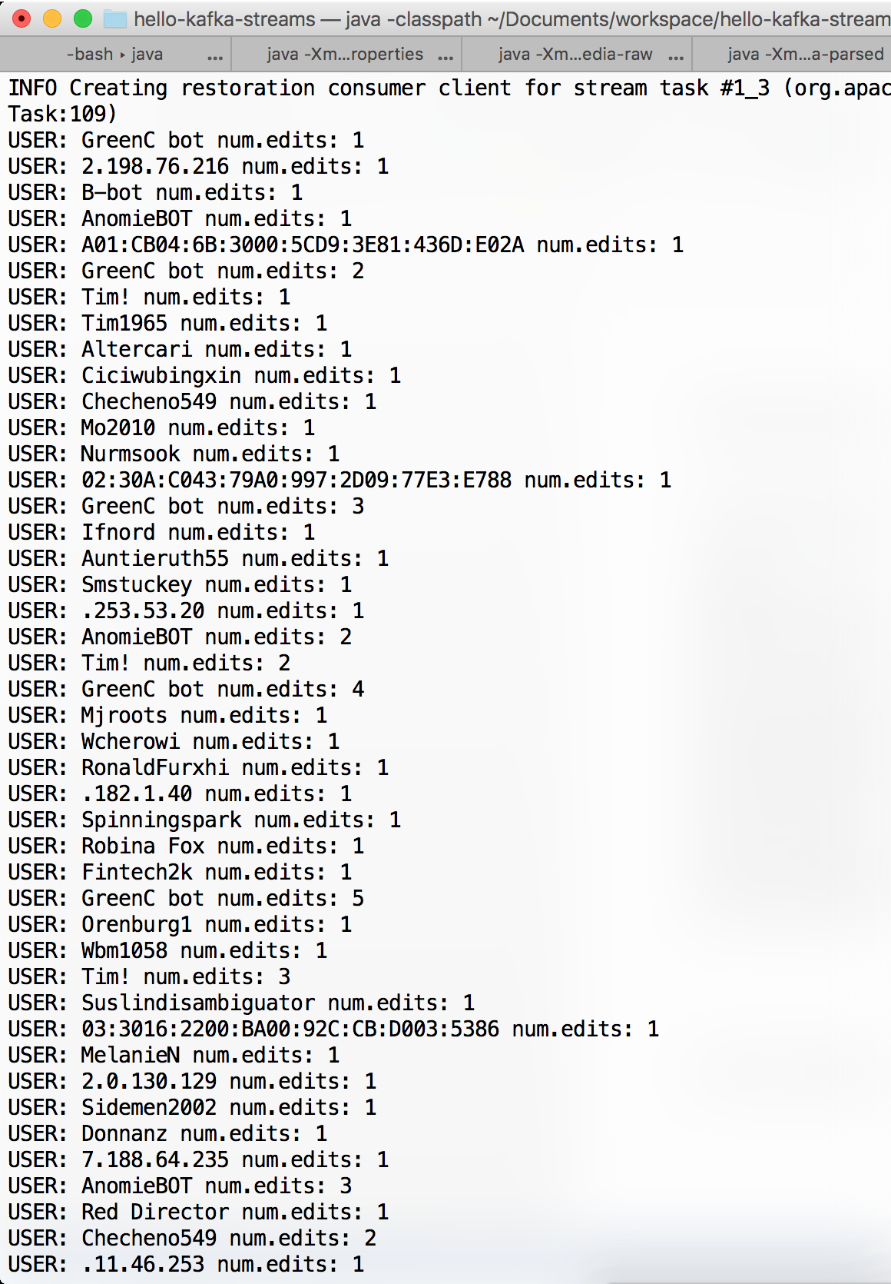

As the program publishes the data into the kafka nodes, the console access of those topic nodes shows us the output dump.

**Real-time streaming data**

./bin/kafka-console-consumer --zookeeper localhost --topic wikipedia-raw

Raw data

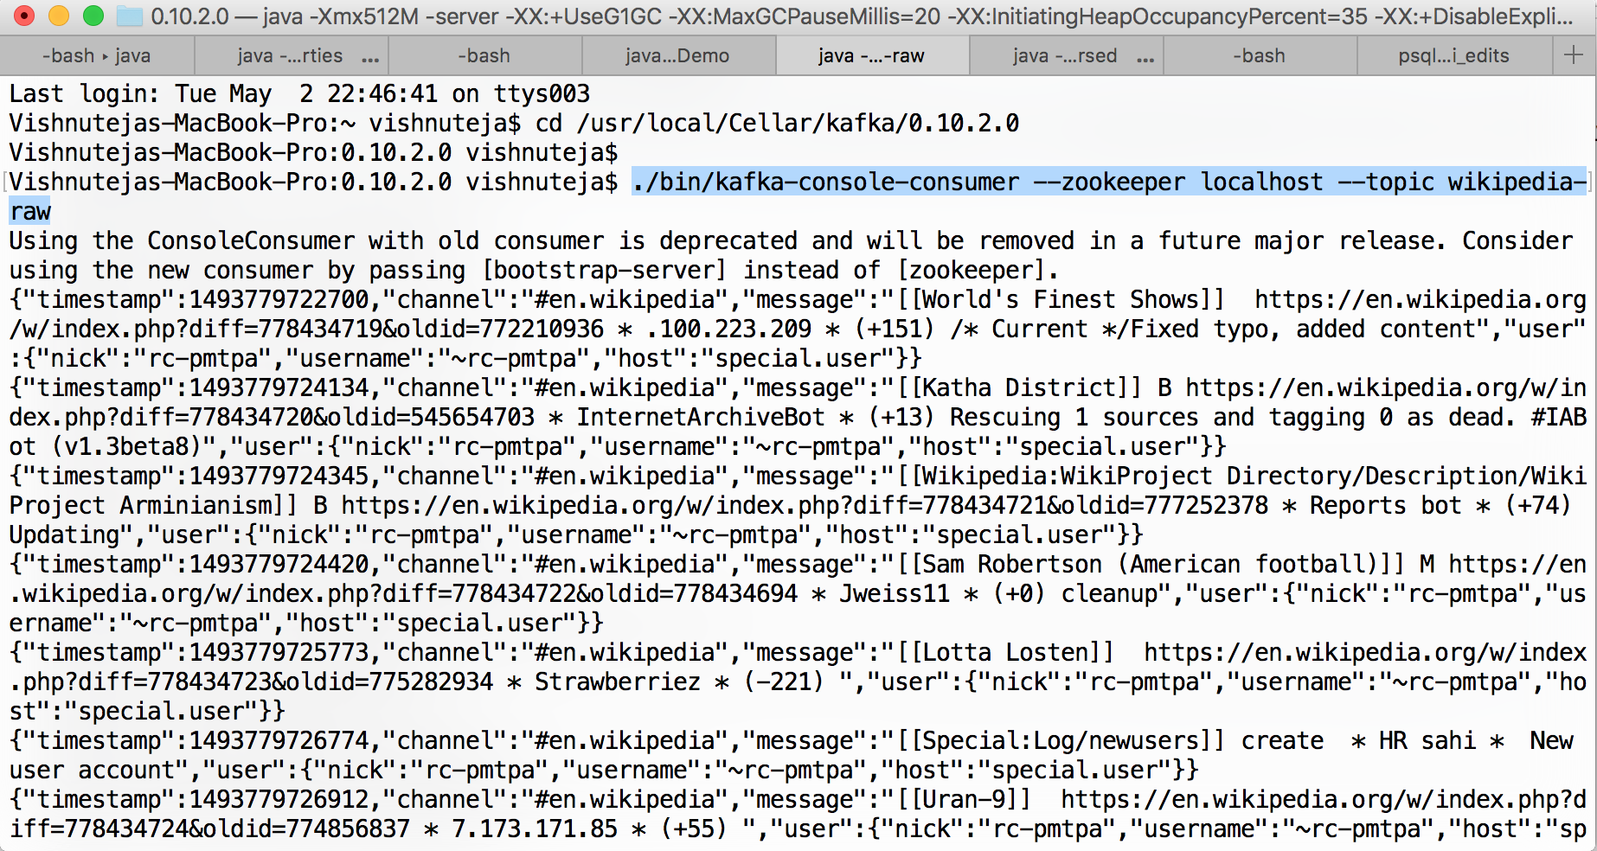

The raw data is in the raw JSON format as shown above. The program parses it to find the information that we need to process. Whereas wikipedia-parsed is the stream of a relevant and formatted JSON data.

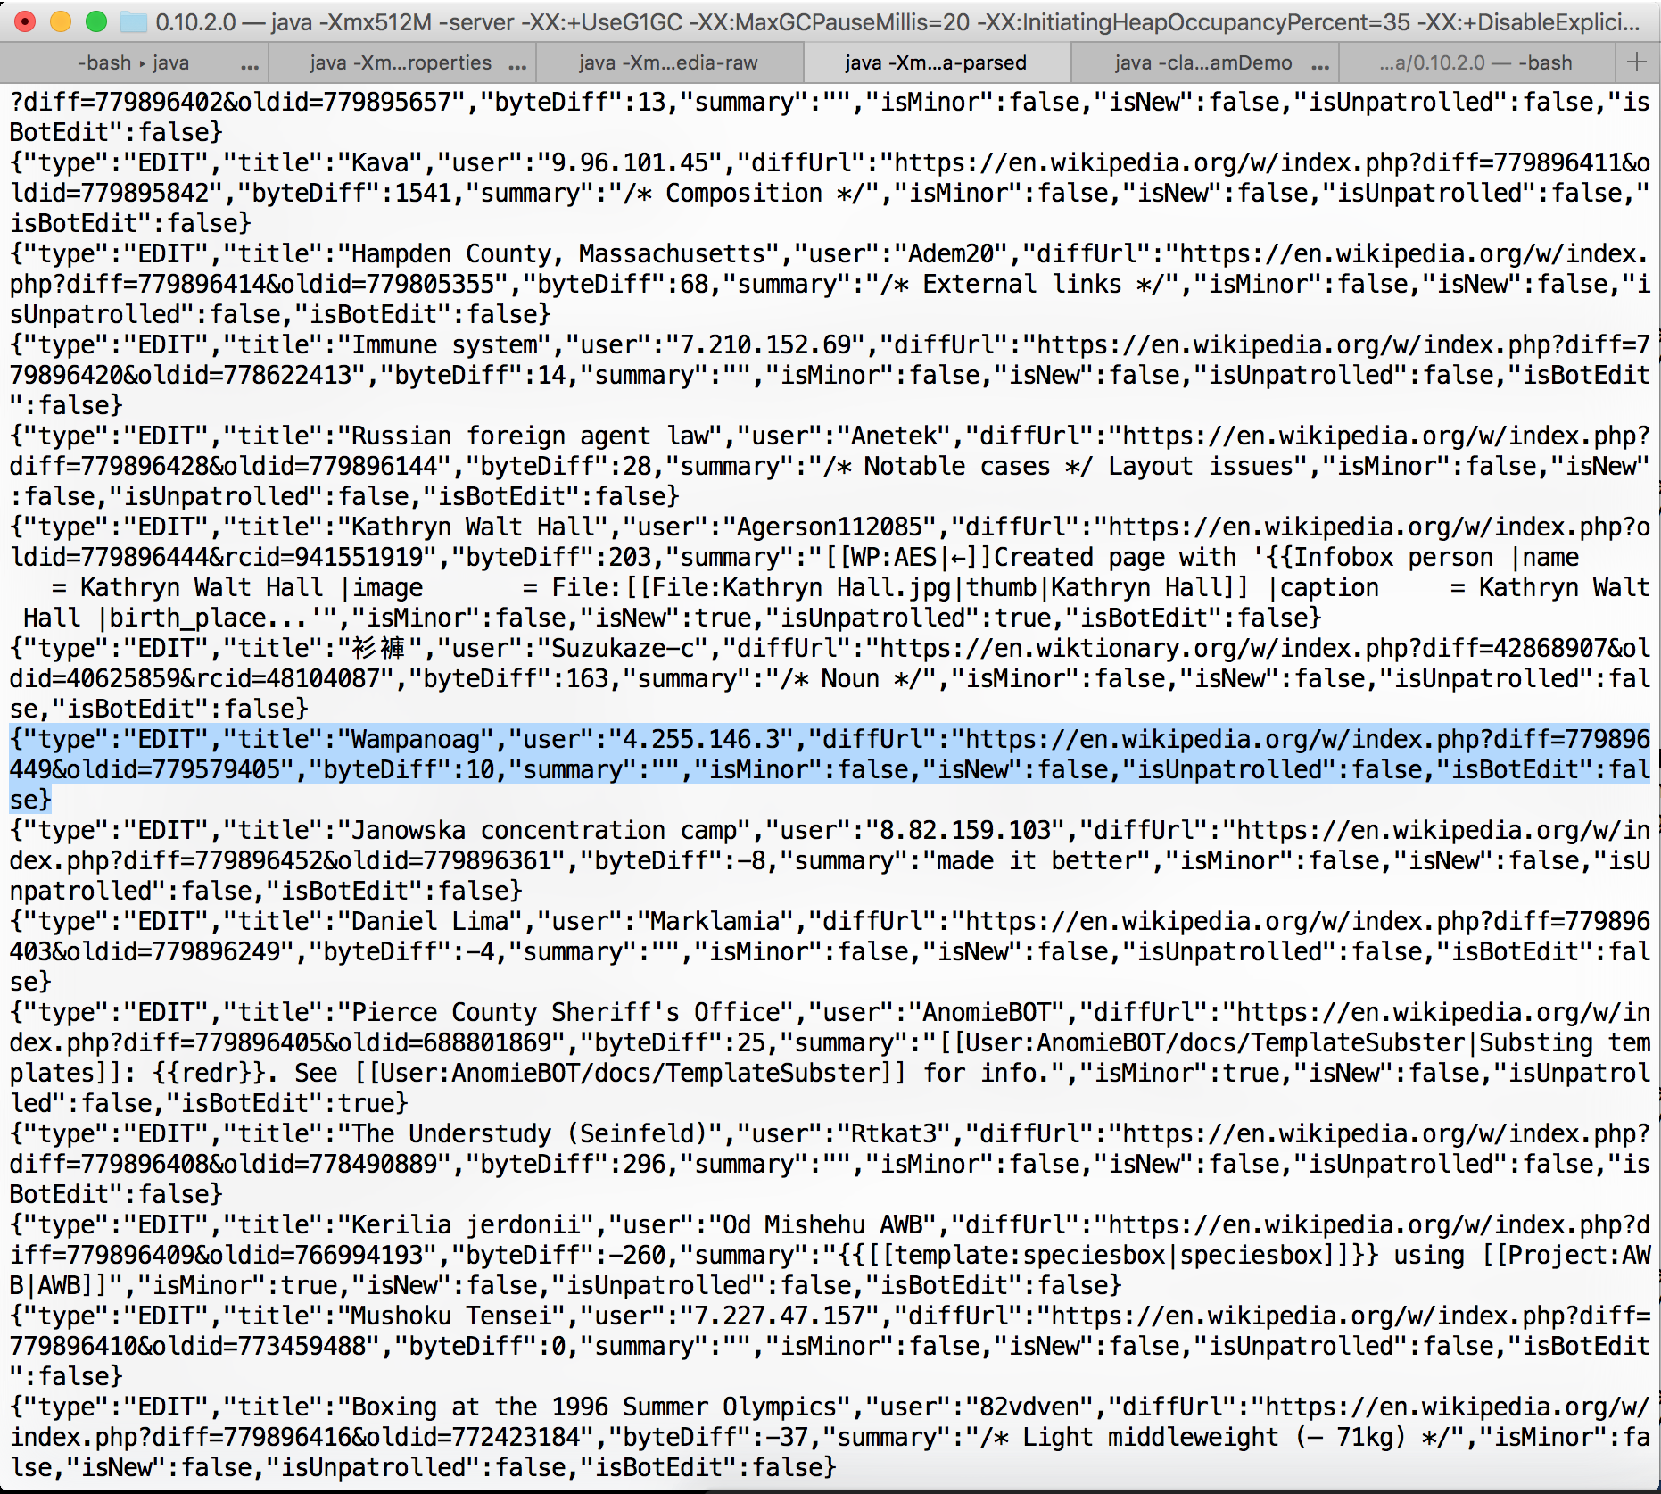

Here in our approach we use the data from Wikipedia-parsed node.

A sample of this data is as follows:

{

"type":"EDIT",

"title":"Wampanoag",

"user":"4.255.146.3",

"diffUrl":"https://en.wikipedia.org/w/index.php?diff=779896449&oldid=779579405",

"byteDiff":10,

"summary":"",

"isMinor":false,

"isNew":false,

"isUnpatrolled":false,

"isBotEdit":false

}

**Process**

Now that we have the real-time JSON data coming from Wikipedia to Kafka servers.

We use Python language with Spark to process the data from the Kafka node.

from pyspark import SparkContext

from pyspark.streaming import StreamingContext

from pyspark.streaming.kafka import KafkaUtils

from pyspark.sql import *

from pyspark.mllib.regression import LabeledPoint

from pyspark.ml.linalg import Vectors, VectorUDT

Here the main libraries from the PySpark are the Spark Context, Streaming context, PySpark SQL and Spark ML.

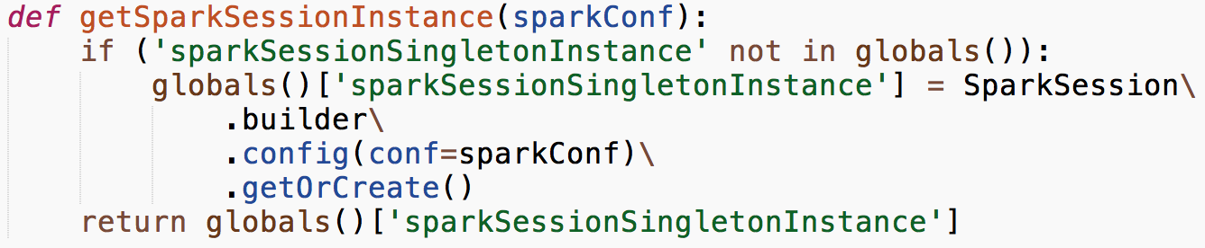

It initiates the global Spark session context.

Create kafka stream using command line arguments to spark-job.



Load JSON from Kafka stream into PySpark.



For each line do the process



Create a table in-memory of Spark for storing the values of edits.



The data looks like this from the dataframe.

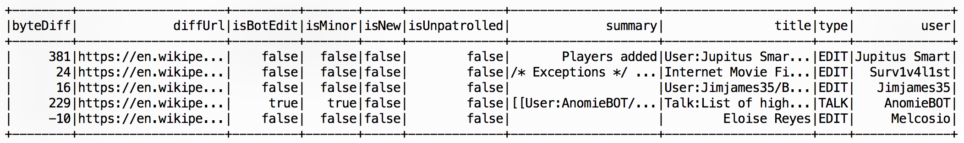

Write the data to PostgreSQL



Add a new column if the bytediff is greater than 0.



After adding the new column, the sample data frame in Spark looks like below.

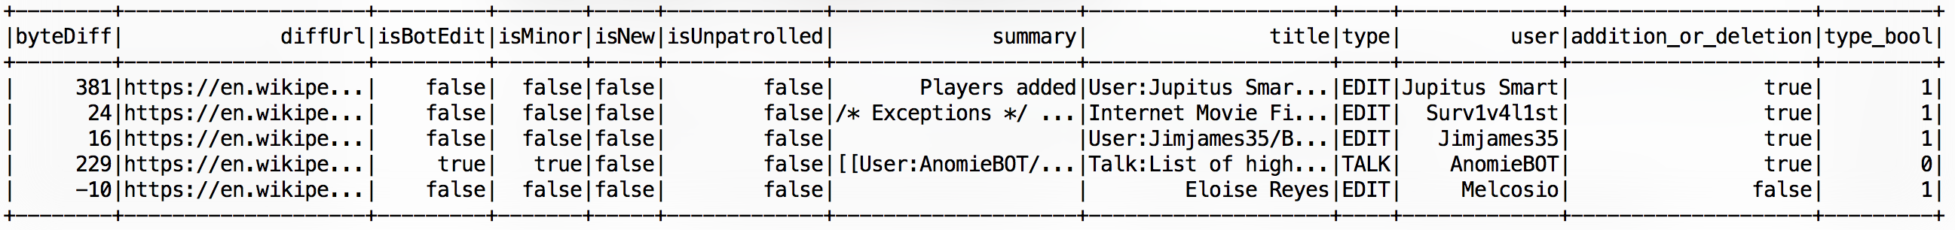

Select the data from Spark.

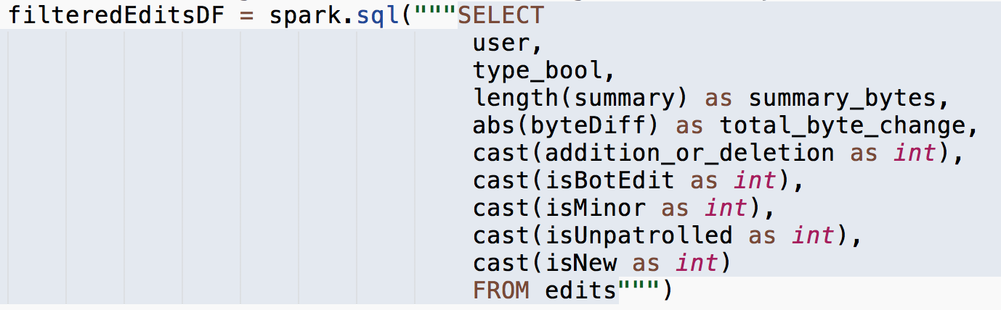

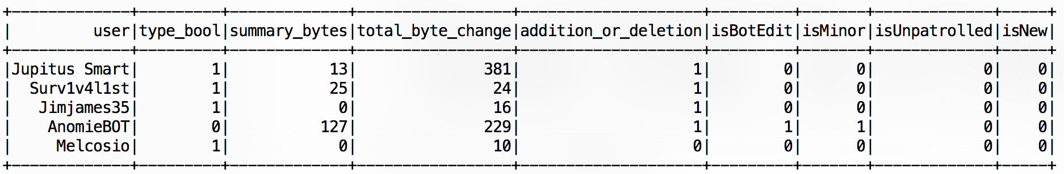

For the purposes of Machine Learning, we ignore user and isBotEdit columns from the data.



Create a new column in Vector for

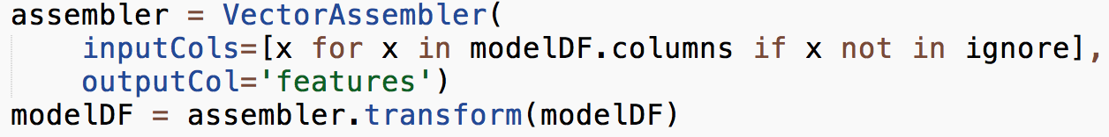

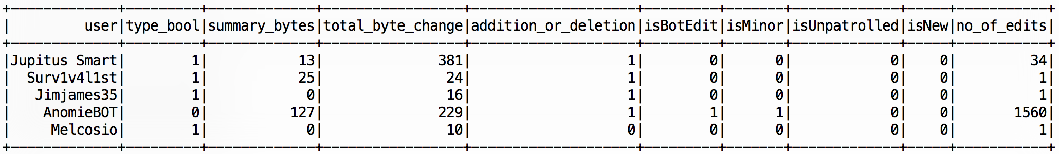

A sample feature vector looks like below:

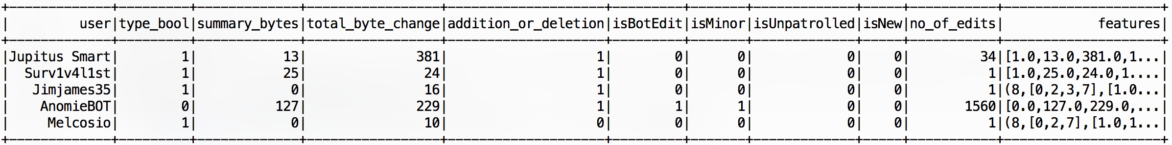

**Principal component analysis (PCA)** is a statistical procedure that uses an orthogonal transformation to convert a set of observations of possibly correlated variables into a set of values of linearly uncorrelated variables called principal components (or sometimes, principal modes of variation). The number of principal components is less than or equal to the smaller of the number of original variables or the number of observations.

After the featured vector, we did the PCA with feature vector and the target variable/label.

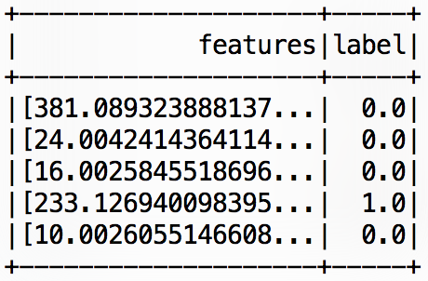

Passing the new Dataframe RDD to Random Forests Machine learning algorithm



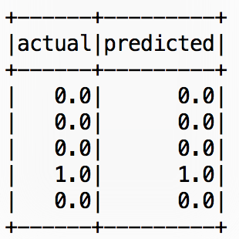

Test Error = 0.0

The error rate is 0 for the current 2 seconds’ data that was fetched from Wikipedia. This varies from one instance of data to another.

After the prediction, we should join the actual values with the predicted values.

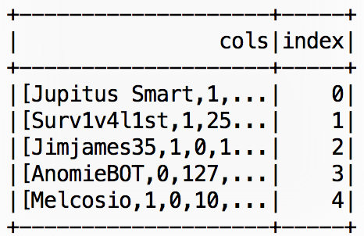

The final RDD/Data frame looks as below:

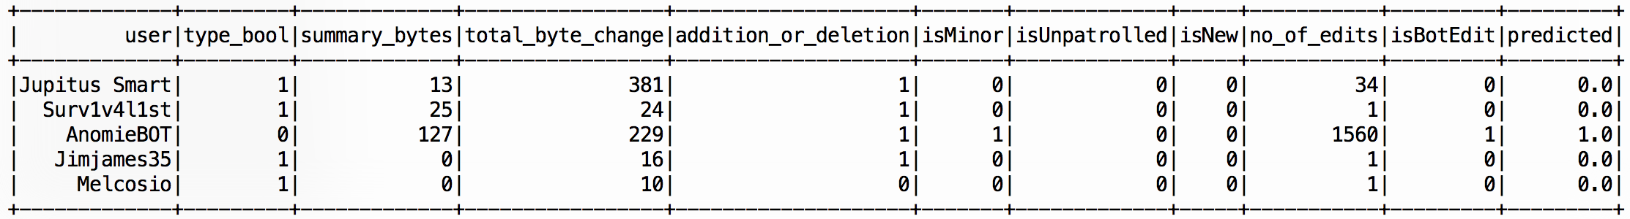

For the persistent storage of Wikipedia data and for the machine learning results we have used PostgreSQL. A sample stored Wikipedia data looks as below:

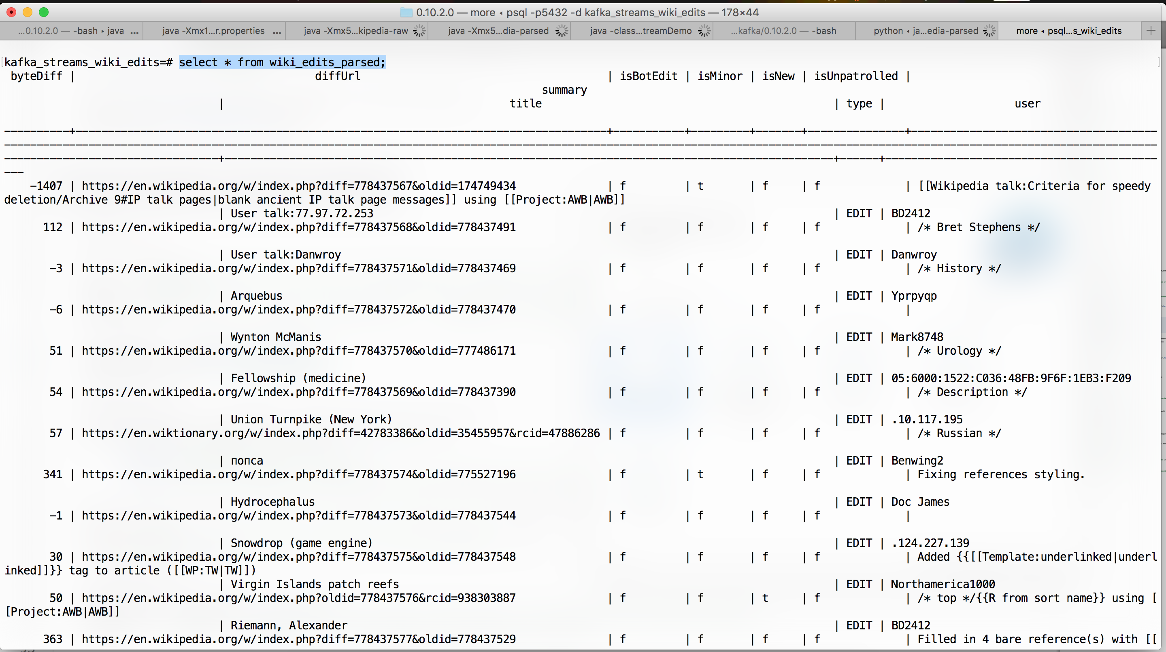

The scored data is as follows from the DB:

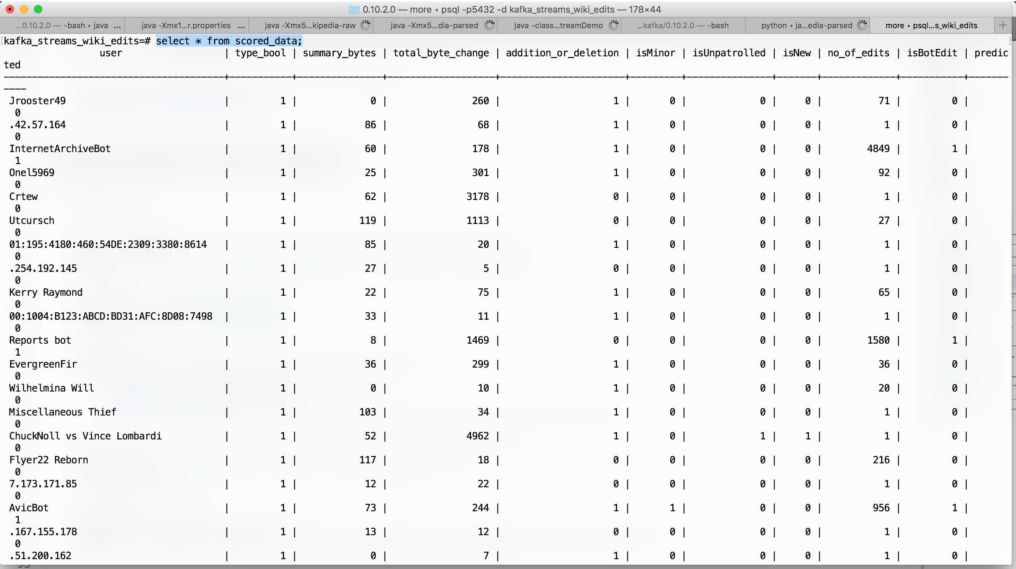

The data is saved as it comes from Wikipedia streams.

**Conclusion:**

This application would serve as a starting point to understand the application of big data systems to solve the real machine learning problems. It helps to get an overview of how organizations or individuals can make use of the Big data technologies. The process in our application involved JSON data, most of the real-time application never be the same. The data cleansing processing must have applied in real time which is a real challenge in big data analytics.

This application has been implemented in a local machine with almost one node for every application. It can make use of distributed system to harness the actual power of these applications. This approach can be applied further to many other application including the social media sites like Twitter, etc., to analyze various user behaviors and do the sentiment analysis in real time.

Spark works near real-time, but has at least 1 sec difference in the data fetching. More new technologies like Apache Storm can be studied and implemented for actual real time implementation.

**References:**

<https://www.confluent.io/blog/hello-world-kafka-connect-kafka-streams/>

<http://spark.apache.org/docs/latest/ml-guide.html>

<https://spark.apache.org/docs/2.1.0/mllib-ensembles.html>